GREEN HOUSE MONITORING AND CONTROLLING BY IBM WATSON

Team name : Innovators

Teams members : 1: D.Madhuri

2: G.Kavya

3: P.Venkat sai

ABSTRACT:

In the 21st century , one of the most significant technologies is the Internet of Things (IoT) which has rapidly developed covering hundreds of applications in the civil, health, military and agriculture areas. In modern greenhooperationuses, several measurement points are required to trace down the local climate parameters in different parts of a large scale greenhouse in order to ensure proper of the greenhouse automation system. This can be done using prototype consisting of DHT11 , mq-135 and mq-2 which are used to measure greenhouses’ temperature, air quality , detection of harmful gases and humidity. Measurement data have been shared with the help of IoT. With this system farmers can control their greenhouse from their mobile phones or computers which have internet connection.

Introduction:

In recent scenario of climate change and its effect on the environment has motivated the farmers to install greenhouses in their fields. But maintaining a greenhouse and its plantation is very labour intensive and majority of them perform vital operations intuitively. Also agricultural researchers are facing shortage of good quality of data which is crucial for crop development. Thus we have developed such a cost effective system using Internet of Things (IoT) technology which is focused on solving these particular problems, our system automates the greenhouse maintenance operations and monitor the growth conditions inside the green house closely.

Very often farmer or Agriculturists rely upon their gut to figure out the vital operations which can have an adverse effect on their production, here sensor data in the fields or in the greenhouse can help farmers plan an optimum time to carry out the harvesting would then ensure that the crop is ready and the value generated is maximized. Thus agriculture is one of the largest use cases of IoT, besides this selective Irrigation, livestock monitoring, remote equipment operation and monitoring, predictive analytics for crops and livestock, etc. with conditions inside the greenhouse closely.

HARDWARE COMPONENTS:

1: DHT-11

DHT-11 sensor is a sensor which is used to calculate and measure the temperature and humidity values. This module can be applied to environmental temperature and environmental humidity.

This sensor includes a resistive-type humidity measurement

component and an NTC temperature measurement component, and connects to a high-performance 8-bit microcontroller, offering excellent quality, fast response, anti-interference ability and cost-effectiveness.

Pin No. Symbol Descriptions

1. DOUT Communication port

2. GND Power ground

3. VCC Positive power supply (3.3V-5.5V)

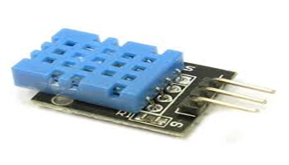

2: NODEMCU ESP8266:

NodeMCU is an open source Lua based firmware for the ESP8266 Wi-Fi SOC from Espressif and uses an on-module flash-based SPIFFS file system. NodeMCU is implemented in C and is layered on the Espressif NON-OS SDK.

The firmware was initially developed as is a companion project to the popular ESP8266-based NodeMCU development modules, but the project is now community-supported, and the firmware can now be run on any ESP module

I/O index ESP8266 pin

0 [\*] GPIO16

1 GPIO5

2 GPIO4

3 GPIO0

4 GPIO2

5 GPIO14

6 GPIO12

7 GPIO13

8 GPIO15

9 GPIO3

10 GPIO1

11 GPIO9

12 GPIO10

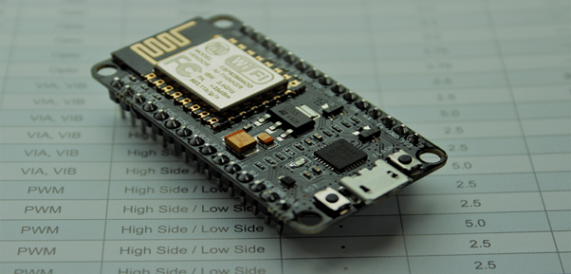

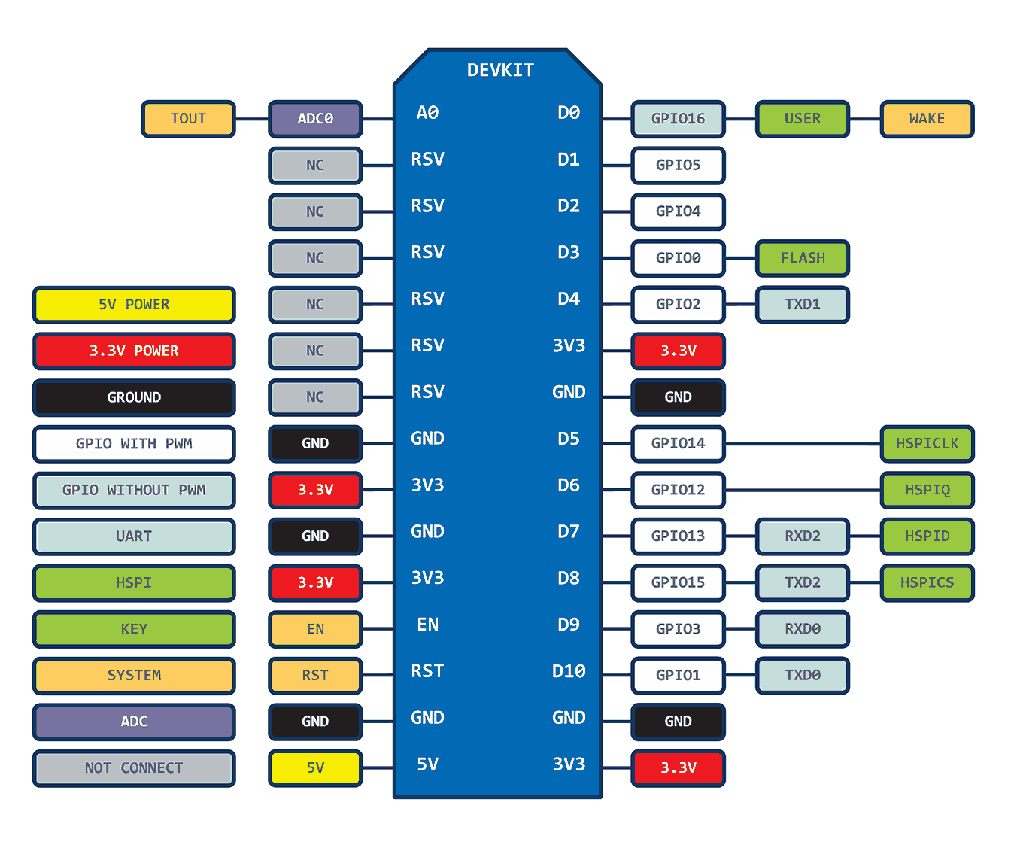

NODEMCU

3:MQ-135:

Air quality sensor for detecting a wide range of gases, including NH3, NOx, alcohol, benzene, smoke and CO2. Ideal for use in office or factory. MQ135 gas sensor has high sensitivity to Ammonia, Sulfide and Benze steam, also sensitive to smoke and other harmful gases. It is with low cost and particularly suitable for Air quality monitoring application.

Features:

* High Sensitivity.
* High sensitivity to Ammonia, Sulfide and Benzene.
* Stable and Long Life.
* Detection Range: 10 - 300 ppm NH3, 10 - 1000 ppm Benzene, 10 - 300 Alcohol.
* Heater Voltage: 5.0V.
* Dimensions: 18mm Diameter, 17mm High excluding pins, Pins - 6mm High
* Long life and low cost

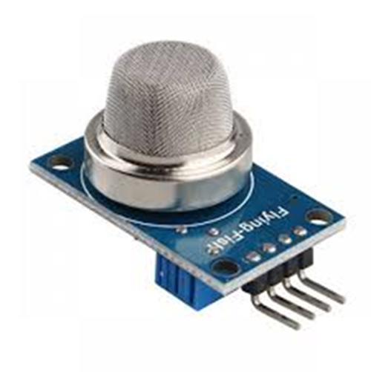

Applications:

* Domestic air pollution detector
* Industrial air pollution detector
* Portable air pollution detector

4:MQ-2:

The Grove - Gas Sensor(MQ2) module is useful for gas leakage detection (home and industry). It is suitable for detecting H2, LPG, CH4, CO, Alcohol, Smoke or Propane. Due to its high sensitivity and fast response time, measurement can be taken as soon as possible. The sensitivity of the sensor can be adjusted by potentiometer.

Features:

* Wide detecting scope
* Stable and long lifetime
* Fast response and High sensitivity

Application Ideas:

* Gas leakage detection.
* Toys.

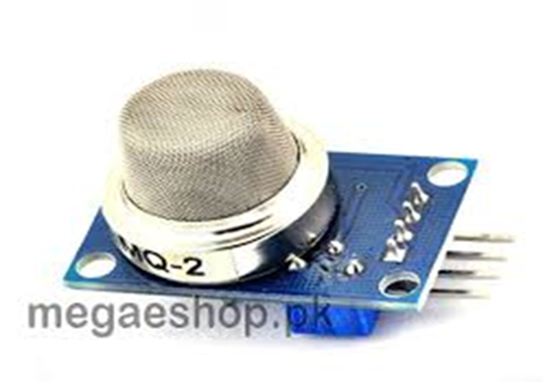

Pin No Pin name

1. VCC (3.3V – 5 V)
2. GND
3. Digital out
4. Analog out